Schedule A
Conditions of Consent (Consent Authority)

GENERAL CONDITIONS
1. | Approved Development  Development Consent is granted for a Recreation Area (Mountain Bike Park), on land known as:  - Lot 1 DP965231, 1 Coalbrook Street, Lithgow NSW 2790  - Lots 1, 2 & 3 DP1110346, 2 Macauley Street, Lithgow NSW 2790  - Lot 2 DP 787403 & Lot 11 DP1240259, 3A State Mine Gully Road, Lithgow NSW 2790  - Lot 10 DP1240259, 4 State Mine Gully Road, Lithgow NSW 2790  - Lot 2 DP876025, 1B Laidley Street Lithgow NSW 2790
1. | Condition Reason: To ensure all parties are aware of the approved development description and development address.
2. | Approved plans and supporting documentation  Development must be carried out in accordance with the following approved plans and documents, except where the conditions of this consent expressly require otherwise.  In the event of any inconsistency between the approved plans and documents, the approved plans prevail. In the event of any inconsistency with the approved plans/documents and a condition of this consent, the condition prevails.
  Approved Plans
  Title | Author | Project | Sheet | Revision | Date
  Aboriginal Due Diligence Assessment Report | OzArk | - | - | - | 14 August 2025
  Biodiversity Development Assessment Report | OzArk | - | - | - | 19 August 2025
  Bushfire Assessment Report | Integrated Consulting | - | - | - | 20 August 2025
  Contamination Report | Consara Contaminated Sites | - | - | - | 11 August 2025
  Detailed Design Report | World Trail PTY LTD | - | - | - | 25 July 2025
  Geotechnical and Mine Subsidence Assessment | RCA Australia | - | - | - | 13 August 2025
  Carpark and Trailhead Concept | World Trail PTY LTD | - | - | - | August 2025
  Operational Plan of Management | PMO 360 PTY LTD | - | - | - | 9 October 2025
  Public Amenities Design Plans  -Floor Plan,  -Front & Right Elevations,  -Rear & Left Elevations | Modus Australia | - | 01,  02,  03 | - | 25 August 2025
  Civil Design Plans | Calare Civil | 20250105 | ES01,  ES02,  ES03,  ES04,  C01,  C02,  C03,  SW01,  SW02 | P3 | 22 August 2025
  Site Survey Plans-Existing | PMO 360 PTY LTD | 2025-AJS-A3 | E1,  E2,  E3,  E4,  E5,  E6,  E7. |  | 8 August 2025
  Site Survey Plans-Proposed | PMO 360 PTY LTD | 2025-AJS-A3 | P1,  P2,  P3,  P4,  P5,  P6,  P7 |  | 8 August 2025
  Statement of Environmental Effects | SJB Planning (NSW) PTY LTD |  |  |  | 9 October 2025
  Statement of Heritage Impact | OzArk |  |  |  | 12 August 2025
  Stormwater Management Plan | Calare Civil |  |  |  | 22 August 2025
  Traffic Impact and Parking Assessment Study | Traffic Engineering Centre |  |  |  | 12 August 2025
2. | Condition Reason: To ensure all parties are aware of the approved plans and supporting documentation that applies to the development.
3. | Contract Works Insurance  The developer is to ensure that Contract Works Insurance is kept current for the duration of the development and must also ensure that all Contractors and Subcontractors working within Council road reserves possess and maintain adequate Public Liability Insurance ($20 million), with copies to be provided to Council prior to commencement of any works. Any potential claims that result from negligent actions performed by Contractors/Subcontractors engaged by the Applicant within Council road reserves will be borne by the Applicant and not Lithgow City Council.
3. | Condition Reason: To ensure the development has no impact to Council’s Assets.
4. | Building Regulations  All building work must be carried out in accordance with the provisions of the current Building Code of Australia, Volume 1.
4. | Condition Reason: To ensure the development complies with the Building Code of Australia.
5. | Disability Discrimination Act  It is the applicant responsibility to ensure compliance with the requirements of the Disability Discrimination Act 1992 (DDA). You are advised to seek advice from the Australian Human Rights and Equal Opportunity Commission in respect of your application.
5. | Condition Reason: To ensure the development complies with the Disability Discrimination Act 1992 (DDA).

GENERAL TERMS OF APPROVAL AND CONCURRENCE REQUIREMENTS
Subsidence Advisory
6. | The General Terms of Approval issued by Subsidence Advisory is to be complied with prior to commencement of operation of the development.  The General Terms of Approval are issued under Schedule B of this consent.
6. | Condition Reason: To ensure the development complies Subsidence Advisory.
Rural Fire Service
7. | Asset Protection Zones  From the start of building works, and in perpetuity to ensure ongoing protection from the impact of bush fires, asset protection zones must be provided as shown on Plan of Bushfire Protection Measures at Figure 13 of the report prepared by Integrated Consulting dated 20 August 2025.  When establishing and maintaining an inner protection area (IPA) the following requirements apply in accordance with the requirements of Appendix 4 of Planning for Bush Fire Protection 2019:  ● tree canopy cover should be less than 15% at maturity;  ● trees at maturity should not touch or overhang the building;  ● lower limbs should be removed up to a height of 2m above the ground;  ● tree canopies should be separated by 2 to 5m;  ● preference should be given to smooth barked and evergreen trees;  ● large discontinuities or gaps in vegetation should be provided to slow down or break the progress of fire towards buildings;  ● shrubs should not be located under trees;  ● shrubs should not form more than 10% ground cover; and  ● clumps of shrubs should be separated from exposed windows and doors by a distance of at least twice the height of the vegetation.  ● grass should be kept mown (as a guide grass should be kept to no more than 100mm in height); and  ● leaves and vegetation debris should be removed.
7. | Condition Reason: to minimise the risk of bush fire attack and provide protection for emergency services personnel, residents and others assisting firefighting activities.
8. | Access Requirements  Property access roads must comply with the following requirements of Table 7.4a of Planning for Bush Fire Protection 2019:  ● property access roads are two-wheel drive, allweather roads;  ● the capacity of road surfaces and any bridges/causeways is sufficient to carry fully loaded firefighting vehicles (up to 23 tonnes), bridges and causeways are to clearly indicate load rating.  ● minimum 4m carriageway width;  ● in forest, woodland and heath situations, rural property roads have passing bays every 200m that are 20m long by 2m wide, making a minimum trafficable width of 6m, at the passing bay;  ● a minimum vertical clearance of 4m to any overhanging obstructions, including tree branches;  ● property access must provide a suitable turning area in accordance with Appendix 3;  ● curves have a minimum inner radius of 6m and are minimal in number to allow for rapid access and  egress;  ● the minimum distance between inner and outer curves is 6m;  ● the crossfall is not more than 10 degrees;  ● maximum grades for sealed roads do not exceed 15 degrees and not more than 10 degrees for unsealed roads; and  ● a development comprising more than three dwellings has formalised access by dedication of a road and not by right of way.  Note: Some short constrictions in the access may be accepted where they are not less than 3.5m wide, extend for no more than 30m and where the obstruction cannot be reasonably avoided or removed. The gradients applicable to public roads also apply to community style development property access roads in addition to the above.
8. | Condition Reason: to minimise the risk of bush fire attack and provide protection for emergency services personnel, residents and others assisting firefighting activities.
9. | Emergency and Evacuation Planning Assessment  A Bush Fire Emergency Management and Evacuation Plan must be prepared and be consistent with the NSW RFS document: A Guide to Developing a Bush Fire Emergency Management and Evacuation Plan.  The Bush Fire Emergency Management and Evacuation Plan should include planning for the early relocation of occupants.  Note: A copy of the Bush Fire Emergency Management and Evacuation Plan should be provided to the Local Emergency Management Committee for its information prior to occupation of the development.
9. | Condition Reason: To comply with the Rural Fire Service Requirements.
Endeavour Energy
10. | Before You Dig  Before commencing any underground activity the applicant must obtain advice from the Before You Dig service.
10. | Condition Reason: To ensure the development complies with Endeavor Energy Requirements.
11. | Earthing  The construction of any building or structure connected to or in close proximity to the electrical network must be properly earthed.
11. | Condition Reason: To ensure the development complies with Endeavor Energy Requirements.
12. | Easement Management  Preference is for no activities to occur in easements and they must adhere to minimum safety requirements.
12. | Condition Reason: To ensure the development complies with Endeavor Energy Requirements.
13. | Emergency Contact  In case of an emergency relating to Endeavour Energy’s electrical network, the applicant should note the Emergencies Telephone is 131 003 which can be contacted 24 hours/7 days.
13. | Condition Reason: To ensure the development complies with Endeavor Energy Requirements.
14. | Look up and Live  Before commencing any activity near overhead power lines the applicant must obtain advice from the Look Up and Live service.
14. | Condition Reason: To ensure the development complies with Endeavor Energy Requirements.
15. | Network Access  Access to the electricity infrastructure may be required at any time particularly in the event of an emergency.
15. | Condition Reason: To ensure the development complies with Endeavor Energy Requirements.
16. | Network Connection  Applicants will need to submit an appropriate application based on the maximum demand for electricity for connection of load.
16. | Condition Reason: To ensure the development complies with Endeavor Energy Requirements.
17 | Protected Works  Electricity infrastructure without an easement is deemed to be lawful for all purposes under Section 53 ‘Protection of certain electricity works’ of the Electricity Supply Act 1995 (NSW).
17 | Condition Reason: To ensure the development complies with Endeavor Energy Requirements.
18. | Prudent Avoidance  Development should avert the possible risk to health from exposure to emissions form electricity infrastructure such as electric and magnetic fields (EMF) and noise.
18. | Condition Reason: To ensure the development complies with Endeavor Energy Requirements.
19. | Public Safety  Workers involved in work near electricity infrastructure run the risk of receiving an electric shock and causing substantial damage to plant and equipment. Endeavour Energy’s public safety training resources, which were developed to help general public/workers to understand why you may be at risk and what you can do to work safely is available via the following link:  http://www.endeavourenergy.com.au/wps/wcm/connect/ee/nsw/nsw+homepage/communitynav/safety/safety+brochures.
19. | Condition Reason: To ensure the development complies with Endeavor Energy Requirements.
20. | Safety Clearances  Any building or structure must comply with the minimum safe distances / clearances for the applicable voltage/s of the overhead power lines. No works or loads must occur within the zone of influence of underground cables.
20. | Condition Reason: To ensure the development complies with Endeavor Energy Requirements.
21. | Service Conductors  Low voltage service conductors and customer connection points must comply with the ‘Service and Installation Rules of NSW’.
21. | Condition Reason: To ensure the development complies with Endeavor Energy Requirements.
22. | Sustainability  Reducing greenhouse gas emissions and helping customers save on their energy consumption and costs through new initiatives and projects to adopt sustainable energy technologies.
22. | Condition Reason: To ensure the development complies with Endeavor Energy Requirements.
23. | Vegetation Management  Landscaping that interferes with electricity infrastructure is a potential safety risk and may result in the interruption of supply.
23. | Condition Reason: To ensure the development complies with Endeavor Energy Requirements.
WaterNSW Requirements
24. | General  The development layout and works shall be implemented in accordance with the plans and supporting documents set out in the following table.  No revisions to site layout or works that will have any impact on water quality, shall be permitted without the agreement of Water NSW.
  Plan Title | Reference | Vers/Iss | Prepared By | Dated
  Existing site-Index | 2025-AJS-A3 Index – Existing | 1 | PMO 360 Pty Ltd | 08/08/2025
  Existing site- Sheet E1-E7 | 2025-AJS-A3 Index - Existing | 1 | PMO 360 Pty Ltd | 08/08/2025
  Proposed site – Index | 2025-AJS-A3 Index - Proposed Development | 2 | PMO 360 Pty Ltd | 26/08/2025
  Proposed site – Sheet P1 to P7 | 2025-AJS-A3 Index – Proposed Development | 2 | PMO 360 Pty Ltd | 26/08/2025
  Floor Plan | Sheet No: 01 | - | MODUS Australia | 25/08/2025
  Elevations | Sheet No: 02 & 03 | - | MODUS Australia | 25/08/2025
  Mountain Bike Trail Sections Standard Bench Construction Standard Drawing | Section 5.3.1 in Detailed Design Report | - | World Trail Pty Ltd | undated
  Trail Sections – Dual Use Class 4 Walking – Green SQ. Riding Standard Drawing | Section 5.3.2 in Detailed Design Report | - | World Trail Pty Ltd | undated
  Trail Sections – MTB Trail Difficulty Rating System Classifications Standard Drawing | Section 5.3.3 to 5.3.7 in Detailed Design Report | - | World Trail Pty Ltd | undated
  Adjustable Rock Matting 900mm Placement and Dimensions  World Trail – Standard Drawing | Section 5.3.8 in Detailed Design Report | - | World Trail Pty Ltd | undated
  Rock Armouring – MTB Placement and Dimensions World Trail – Standard Drawing | Section 5.3.9 in Detailed Design Report | - | World Trail Pty Ltd | undated
  Imported Trail Surfacing Trail Surface Treatment Standard Drawing | Section 5.3.10 in Detailed Design Report, Project No. WT2019-107, Drawing no. WTSTD-063-YV | C | World Trail Pty Ltd | 6/02/2024
  Rock Walling – up to 500mm – MTB Placement and Dimensions World Trail – Standard Drawing | Section 5.3.11 in Detailed Design Report, Project No. WT2019-107, Drawing no. WTSTD-034-YV | B | World Trail Pty Ltd | 6/02/2024
  Rock Walling – up to 1000mm Placement and Dimensions Standard Drawing | Section 5.3.12 in Detailed Design Report, Project No. WTSTD-2021, Drawing no. WTSTD-067-YV | B | World Trail Pty Ltd | 6/02/2024
  Imported Trail Surfacing Trail Surface Treatment Standard Drawing | Section 5.3.10 in Detailed Design Report, Project No. WT2019-107, Drawing no. WTSTD-063-YV | C | World Trail Pty Ltd | 6/02/2024
  Erosion and Sediment Control Plan | Job No: 20250105  Drawing No: ES01 | P3 | Calare Civil Pty Ltd | 22/08/25
  Erosion and Sediment Control Notes | Job No: 20250105  Drawing No: ES02 & ES03 | P3 | Calare Civil Pty Ltd | 22/08/25
  Soil and Water Management Notes | Job No: 20250105  Drawing No: ES04 | P3 | Calare Civil Pty Ltd | 22/08/25
  Preliminary Overall Site Plan | Job No: 20250105  Drawing No: C01 | P3 | Calare Civil Pty Ltd | 22/08/25
  Preliminary Site Cross Sections | Job No: 20250105  Drawing No: C03 | P3 | Calare Civil Pty Ltd | 22/08/25
  Stormwater Management Plan | Job No: 20250105  Drawing No: SW01 | P3 | Calare Civil Pty Ltd | 22/08/25
  Typical Details | Job No: 20250105  Drawing No: SW02 | P3 | Calare Civil Pty Ltd | 22/08/25
  Supporting Documents
  Statement of Environmental Effects | Ref: 9929A | Final Rev 1 | SJB Planning (NSW) Pty Ltd | 9 October 2025
  Lithgow Mountain Bike Park – Detailed Design Report | - | Final | World Trail Pty Ltd | 25/7/2025
  Lithgow MTB Trailhead Concept | - | Final Concept | World Trail Pty Ltd | August 2025
  Stormwater Management Plan | Job No: 2025.0105 | P3 | Calare Civil Pty Ltd | 22/08/2025
  Operational Plan of Management including Waste Management | Document no: LMBPOPS01 | Rev3 | PMO 360 Pty Ltd | 09/10/25
  Desktop Geotechnical and Mine Subsidence Assessment | Ref:17539-201/2 | 2 | RCA Australia | 13.08.25
  Stage 1 Environmental Site Assessment | Ref: C241028_RPT_11AUG2025 Revision 1 | 1 | CONSARA Pty Ltd | 11 August 2025
  Biodiversity Development Assessment Report | Job No: 4470 | V3.1 | OzArk Environment & Heritage | 19/08/2025
24. | Reason for Condition: Water NSW has based its assessment under State Environmental Planning Policy (Biodiversity and Conservation) 2021 on this version of the development.
25. | Sewerage Infrastructure  The public toilet/amenities shall be connected to Council’s reticulated sewerage system and shall ensure that all new sewerage infrastructure is designed, located, and installed in accordance with Council’s requirements and be to the satisfaction of Council.
25. | Reason for Condition: To ensure that the design and operation of the sewerage infrastructure is undertaken in a way that minimises the risk of sewage overflows to ensure a sustainable neutral or beneficial effect on water quality over the longer term.
26. | Stormwater Management  - All stormwater management measures as shown on the Stormwater Management Plan shall be incorporated in the final stormwater management plan. The final plan shall:  - be prepared prior to the issuance of a Construction Certificate and approved by the Principal Certifier  - include:  o detailed design of the stormwater drainage network (including pits and pipes) within the carpark area so as not to compromise the chitter heap cap.  o batters around the carpark site.  o bioretention basin and associated energy dissipator.  - be implemented.  - The bioretention basins shall:  - be located and constructed as specified in the Stormwater Management Plan.  - have the filter media installed after the construction of the access driveway and carpark is completed and all ground surfaces have been stabilised.  - be designed consistent with Adoption Guidelines for Stormwater Biofiltration Systems Version 2 (Payne et al, 2015, Melbourne, CRC for Water Sensitive Cities).  - incorporate the following:  o a minimum surface and filter area of 150m².  o an extended detention depth of 300mm.  o a filter depth (excluding transition layers) of a minimum of 400 mm above the underdrains.  o a network of underdrains with a 1.5m spacing.  o a filter media consisting of a clean sandy loam with a certified median particle diameter of 0.5mm, a maximum orthophosphate concentration of 40mg/kg and a maximum total nitrogen concentration of 400mg/kg.  - be planted with appropriate deep-rooted, moisture-tolerant vegetation protected by rock mulch (grass and turf is not appropriate vegetation and organic mulch is not suitable).  - direct all discharge and overflow towards the unnamed tributary located west of the site via an armoured discharge point and energy dissipator such that discharge does not cause erosion.  - ensure the discharge point is consistent with the requirements of any Controlled Activity Approval under the Water Management Act 2000 from the Department of Climate Change, Energy, the Environment and Water.  - be accessible from the driveway by machinery to facilitate cleaning, monitoring, and maintenance of the structures.  - be permanently protected from heavy vehicle damage by guardrails, castellated kerb, bollards, or similar structures, with a sign to be erected to advise of its nature and purpose in water quality management, and  - be protected by sediment and erosion control measures during any construction and post-construction phase until the ground surface is re-vegetated or stabilised.  - The trail head facilities, sealed access driveway and carpark shall be constructed as shown in the Preliminary Overall Site Plan. The access driveway and carpark shall:  - ensure all batters and verges associated with the access way are vegetated and stabilised with bitumen and jute matting or similar as soon as possible after construction, and  - drain to stormwater pits and directed to the bioretention basin located at the southwest corner of the carpark area.  - No variation to stormwater treatment or management that will have any impact on water quality shall be permitted without prior agreement of Water NSW.  - A suitably qualified stormwater consultant or engineer shall certify in writing to Water NSW and the Principal Certifier prior to the issuance of an Occupation Certificate that all stormwater management measures have been installed as per these conditions of consent and are in a functional state.
26. | Reason for Condition: To ensure appropriate stormwater management measures are designed, implemented and maintained to achieve a sustainable neutral or beneficial impact on water quality, particularly during wet weather, over the longer term.
27. | Mountain Bike Trails  The mountain bike trails shall:  - be constructed with appropriate surfacing, in accordance with the recommendations specified in section 5.3 of the Lithgow Mountain Bike Park – Detailed Design Report.  - have drainage installed as specified in Section 5.3.10 in the Lithgow Mountain Bike Park – Detailed Design Report and the outlets stabilised by an energy dissipater such that discharge does not cause erosion.  - have appropriate stabilisation in trail sections that are often wet (for example adjustable rock mounting or rock armouring).  - be stabilised and armoured appropriately where the slope exceeds 10 percent.  - have all infall and outfall drains, batters and verges (where provided) stabilised as soon as possible after construction.  - have the drains, batters and verges adequately armoured in steeper areas where the slope exceeds 10 percent, and  - be consistent with the requirements of any Controlled Activity Approval under the Water Management Act 2000 from the Department of Climate Change, Energy, the Environment and Water where the trails intersect existing watercourses.
27. | Reason for Condition: To ensure the trails and associated stabilisation and drainage measures are appropriately managed and maintained to ensure an overall and sustainable neutral or beneficial impact on water quality over the longer term.
28. | Operational Environmental Management Plan  - An Operational Environmental Management Plan (OEMP) shall be prepared by a person with knowledge and experience in the preparation of such plans and may be incorporated in the site’s overall Operational Plan of Management. The OEMP shall:  - be prepared in consultation with Water NSW, prior to the issuance of an Occupation Certificate.  - be provided to the site’s owner and appointed management representative.  - include details on the location, description and nature of stormwater management measures such as pits and pipes, and bioretention basin.  - include details on the location, description and nature of adequate trail drainage and stabilisation measures such as rock platforms, drainage installed across the trails to manage runoff, and adjustable rock matting and rock armouring.  - outline details regarding site use during adverse weather conditions (particularly during heavy and/or sustained rainfall).  - outline the responsibilities and detailed requirements for the inspection, monitoring, and maintenance of all stormwater management and trail drainage and stabilisation measures, including the frequency of such activities particularly after wet weather.  - identify the individuals or positions responsible for inspection and maintenance activities including a reporting protocol and hierarchy, and  - include checklists for recording inspections, monitoring, and maintenance activities particularly for the bioretention basin and trail drainage and stabilisation measures.  - All stormwater management devices shall be monitored, maintained and managed as per the Operational Environmental Management Plan.
28. | Reason for Condition: To ensure appropriate stormwater treatment and quality control measures are designed, implemented and maintained to achieve a sustainable neutral or beneficial impact on water quality, particularly during wet weather, over the longer term.
29. | Construction Activities  - A Soil and Water Management Plan shall be prepared in consultation with Water NSW and implemented for all works, by a person with knowledge and experience in the preparation of such plans. The Plan shall:  - be prepared prior to the issuance of a Construction Certificate and be to the satisfaction of the Principal Certifier.  - be specifically implemented for any excavation and tree removal at the site during construction of the trails and installation of creek crossings.  - meet the requirements outlined in Chapter 2 of NSW Landcom’s Soils and Construction: Managing Urban Stormwater (2004), and  - include controls to prevent sediment or polluted water leaving the construction area or entering any stormwater drain or natural drainage system.  - The Soil and Water Management Plan shall be implemented, and no works shall commence until effective erosion and sediment controls have been installed. The controls shall be regularly inspected, maintained, and retained until works have been completed and ground surface stabilised or groundcover re-established.
29. | Reason for Condition: To manage adverse environmental and water quality impacts during the construction phase of the development and to minimise the risk of erosion, sedimentation, and pollution within or from the site during this construction phase.
Department Climate Change, Energy, the Environment and Water – Water Group
30. | The General Terms of Approval issued by Department Climate Change, Energy, the Environment and Water – Water Group is to be complied with prior to commencement of operation of the development.  The General Terms of Approval are issued under Schedule C of this consent.
30. | Condition Reason: To ensure the development complies Department Climate Change, Energy, the Environment and Water – Water Group.
Subsidence Advisory
31. | The General Terms of Approval issued by Subsidence Advisory is to be complied with prior to commencement of operation of the development.  The General Terms of Approval are issued under Schedule B of this consent.
31. | Condition Reason: To ensure the development complies Subsidence Advisory.
The Department of Planning, Housing & Infrastructure - Crown Lands (the Department),
32. | Crown Land Management Act 2016  The applicant is required to hold a current licence issued by the Department of Planning, Housing & Infrastructure – Crown Lands under the Crown Land Management Act 2016, prior to the commencement of construction, the duration of construction, and ongoing occupation of the Crown land known as Lot 1 DP 965231.
32. | Reason for Condition: To Comply with the Crown Land Management Act 2016.
NSW National Parks and Wildlife Service
33. | Survey  The boundary of the park be identified by survey, with placement of temporary construction-level fencing where trail alignments adjoin the park boundary (where practicable). This includes signage to prevent unauthorised access to the park during the construction phase.
33. | Reason for condition: To comply with NSW National Parks and Wildlife Service Recommendations and Guidelines.
34. | Access  No access to or works on the park are to occur as part of this proposal unless written authorisation is granted by NPWS under the National Parks and Wildlife Act 1974 or the National Parks and Wildlife Regulation 2019. In particular, the park is not to be used to gain access to the development site or for the storage of materials, equipment, workers’ vehicles or machinery at any time.
34. | Reason for condition: To comply with NSW National Parks and Wildlife Service Recommendations and Guidelines.
35. | Traffic Management Plan  A Traffic Management Plan be provided to NPWS prior to preparation of the NPWS access consent to enable effective consideration of construction traffic on the NPWS trail network.
35. | Reason for condition: To comply with NSW National Parks and Wildlife Service Recommendations and Guidelines.
36. | Stormwater  All work to be undertaken in accordance with Managing Urban Stormwater, Soils & Construction (Landcom, 2004).
36. | Reason for condition: To comply with NSW National Parks and Wildlife Service Recommendations and Guidelines.
37. | Visitor Management Plan and Emergency Response Plan  As the proposal intersects with NPWS estate, with visitor access via the Gardens of Stone SCA, a visitor management plan and emergency response plan should be developed in collaboration with NPWS and key stakeholders prior to completion.
37. | Reason for condition: To comply with NSW National Parks and Wildlife Service Recommendations and Guidelines.
38. | Tour Operations  All tour operations associated with the proposal, including shuttle services and commercial tour operators, must be registered with the NPWS Parks Eco Pass program to access the Gardens of Stone SCA.
38. | Reason for condition: To comply with NSW National Parks and Wildlife Service Recommendations and Guidelines.
39. | Signage Plan  A signage plan will be required to support the proposal, including signage which appropriately communicates risk and safety messaging to users. The signage plan must be developed in collaboration with NPWS to ensure alignment with relevant policies and procedures.
39. | Reason for condition: To comply with NSW National Parks and Wildlife Service Recommendations and Guidelines.
40. | Ongoing Operations  A working group or sub-committee should be established with key stakeholders to support ongoing operations and management of the proposal. Key stakeholders include Lithgow City Council, the Central Tablelands Mountain Bike Club, State Mine Heritage Museum, Crown Lands and private landowners.
40. | Reason for condition: To comply with NSW National Parks and Wildlife Service Recommendations and Guidelines.
41. | Operational Management Plan  An operational management plan should be prepared and reviewed every 12 months, in collaboration with NPWS and key stakeholders.
41. | Reason for condition: To comply with NSW National Parks and Wildlife Service Recommendations and Guidelines.
Heritage NSW
42. | Heritage and Archaeological Impacts  - All ground disturbing works for the trails must remain within the study area to minimise the risk of inadvertent harm to the key heritage fabric of the State Mine Heritage Park.  - The construction of the trail head and car parking area within the heritage curtilage of the State Mine Heritage Park must remain within the assessed footprint.  - The management measures provided in Section 7 will be followed to avoid impact to HS01 and HS02.  - It is assessed that there is a low potential for archaeological deposits or significant historic items within the study area. However, if during the construction of the project suspected significant historic items are encountered, the Unanticipated Finds Protocol provided as Appendix 1 will be followed.
Reason for condition: To comply with Heritage NSW Recommendations and Guidelines.

FEES, CHARGES AND CONTRIBUTIONS CONDITIONS
43. | Contributions  Prior to the issue of a Construction Certificate the applicant shall pay to Council a Section 7.12 contribution of $72,128.58 in accordance with the Lithgow City Council Local Infrastructure Contributions Plan (Section 7.12) 2024-2026. It is advised that the level of contribution in this plan may be adjusted at the time of actual payment, in accordance with the provisions of the Lithgow City Council Local Infrastructure Contributions Plan (Section 7.12) 2024-2026.
43. | Condition Reason: To demonstrate compliance and ensure fees are paid in accordance with the Lithgow Contributions Plan.
44. | Water and/or Sewerage Development Contributions  The approved development is subject to Council’s Water and/or Sewerage Development Contributions. Contributions are levied in accordance with the Water Directorate Section 64 of the Local Government Act 1993 which allows Council to exercise this function pursuant to Division 5 of Part 2 of Chapter 6 of the Water Management Act 2000.  The amount of the contribution per Equivalent Tenement is published in Council’s adopted Fees and Charges in accordance with the Development Service Plans for Water Supply and Sewerage. Contributions are subject to annual CPI increases.
44. | Condition Reason: To demonstrate compliance and ensure fees are paid in accordance with the Lithgow Council’s Development Servicing Plan.

CONSTRUCTION WORK

BEFORE CONSTRUCTION WORK COMMENCES
45. | Construction Certificate required  Construction shall not commence on the site, including the placement of temporary buildings, site sheds, earthworks, site excavation, filling or other site preparation works (with the exception of site survey work), prior to the issue of a Construction Certificate by Council or a nominated Certifier.
45. | Condition Reason: To ensure site management measures are implemented during the carrying out of site work.
46. | Section 68 – Local Government Act  Prior to the commencement of any plumbing OR sanitary drainage work and prior to the issue of the Construction Certificate for connection to Council’s Water, Sewer and Stormwater Services, separate approval must be obtained under Section 68 of the Local Government Act 1993. The Section 68 Application shall be assessed by Lithgow City Council as the regulatory authority for any activity under Section 68 Table B for water and wastewater.
46. | Condition Reason: To ensure the development is serviced by suitable water, sewer and stormwater connections, in accordance with Council’s Policy.
47. | Water and Sewer Requirements  a) A Section 68 (S68) application must be submitted to Council prior to any construction certificate being issued. The application must be accompanied with all drawings of site showing council infrastructure, proposed connections to infrastructure and appurtenance.  b) The Section 68 application shall be accompanied by detailed site servicing plans and supporting information including:  a. The location of existing Council water and sewer infrastructure.  b. Proposed water and sewer service connection points to Council’s reticulated networks.  c. All associated appurtenances including water meters, sewer boundary risers, inspection openings, and backflow preventions devices.  d. A water supply servicing strategy for the development.  e. A hydraulic assessment prepared by a licensed plumber or suitable qualified professional demonstrating adequate pressure, and flow to service the development.  f. Water Service shall be designed by a qualified person to ensure adequate flow and pressure to all fixtures.  g. A sewerage servicing strategy confirming gravity connections.  h. The design and installation of the new sewer tie servicing to proposed development.  i. If a council sewerage system is not present adjacent to the proposed development, the developer shall design and install a sewer to service the development, connecting to the existing council sewer infrastructure, in accordance with Council standards.  c) A water service shall be provided to service the amenities and associated facilities in accordance with Council Water Services and Meter Installation Policy 3.1 and Council Containment Backflow Policy 3.4.  d) The development shall be connected to Council’s reticulated sewer network in accordance with the Council Sewer Connection Policy 3.5.  e) Water supply for Fire Service installation is to be in accordance with Lithgow City Council Policy 3.6.  f) All water service connections to Council’s reticulated network shall be carried out by a licensed plumber.  g) All water and sewer works must be designed and constructed in accordance with:  a. Council standards and specifications  b. WSAA Regional Codes,  c. Relevant Australian Standards and must be approved by Council prior to construction.  h) All plumbing and drainage works must be carried out by a licensed tradesperson in accordance with:  a. Plumbing and Drainage Act 2011,  b. AS/NZS 3500 Plumbing and Drainage Standards,  c. National Construction Code (Building Code of Australia).  - Council inspections are required at nominated stages of construction. A minimum of 48 hours’ notice shall be provided to Council to arrange inspections. A certificate of Compliance shall not be issued until the works have been inspected and accepted by Council.
  Installation of sewer service including Sewer Boundary Rise (DN150) | Prior to backfilling
  At the completion of all plumbing and drainage works | Prior to issue of occupation certificate
47. | Condition Reason: To ensure with the Section 68 Local Government Act 1993- Water and Sewer Requirements.
48. | Operational Management Plan  An Operational Management Plan is to be submitted to and approved by Council prior to the issue of the Construction Certificate.  The Operational Management Plan is to address relevant matters including:  - Visual amenity,  - Privacy,  - Activities proposed for the development,  - Noise,  - Alarms, (Back to base alarm system),  - Lighting to all areas including the car park, walkways and pedestrian access points,  - Visitor and traffic hours of operations,  - Weekly Waste Management,  - Retention of CCTV camera records for 30 days.  - Hours of operational for cleaners, and other employees,  - Register with Bizkeys, after hours contacts with Lithgow Police.  - Security company patrols as the area currently predominantly vacant the area will have limited natural surveillance.  - Signage –  - All ingress and egress points to be well defined and clearly marked with signage and traffic flow arrows.  - Clearly marked directional flow of traffic in car park.  - CCTV in operation and security patrols on premises.  - Any other potential operational impacts.  - The Management Committee is to be defined with the number of committee members, meetings, regular safety audit details and safety of the tracks, maintenance and management procedures.  This plan is to be implemented, once approved by Council, with the provisions of the management plan being fully complied with and maintained throughout the duration of the development.  The plan is to be reviewed annually by the site operator, with any proposed changes submitted to Council for consultation and approval prior to action.
48. | Condition Reason: to ensure minimal impacts occur to the surrounding environment.
49. | Ecosystem credit retirement conditions  - Prior to issue of construction certificate the class and number of ecosystem credits in Table 1 must be retired to offset the residual biodiversity impacts of the development.  - The requirement to retire credits in condition 1.1 may be satisfied by payment to the Biodiversity Conservation Fund of an amount equivalent to the class and number of ecosystem credits, as calculated by the BAM Credit Calculator (BAM-C).  - Evidence of the retirement of credits or payment to the Biodiversity Conservation Fund in satisfaction of condition 1.1 must be provided to the Council prior to issue of construction certification.  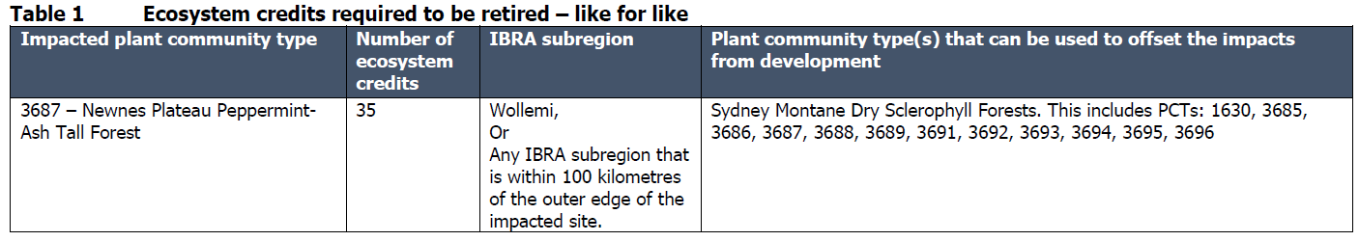
49. | Condition Reason: To comply with the Biodiversity Conservation Act 2016.
50. | Species credit retirement conditions  - Prior to issue of construction certificate the class and number of species credits in Table 2 must be retired to offset the residual biodiversity impacts of the development.  - The requirement to retire credits outlined in condition 2.1 may be satisfied by payment to the Biodiversity Conservation Fund of an amount equivalent to the class and number of species credits, as calculated by the BAM Credit Calculator (BAM-C).  - Evidence of the retirement of credits or payment to the Biodiversity Conservation Fund in satisfaction of Table 2 requirements must be provided to the consent authority prior to issue of construction certification.  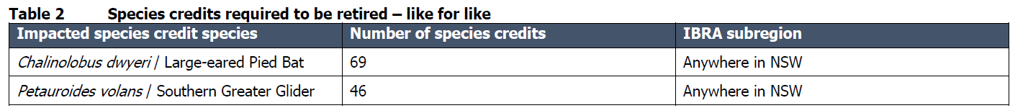
50. | Condition Reason: To comply with the Biodiversity Conservation Act 2016.
51. | Avoid and minimise measures conditions  1. Prior to the issue of construction certificate, an Erosion and Sediment Control Plan must be prepared to the satisfaction of Council. The Erosion and Sediment Control Plan may form part of a Construction Environmental Management Plan.  2. Prior to issue of construction certificate, a Biodiversity Management Plan must be prepared to the satisfaction of Council. The Biodiversity Management Plan may form part of a Construction Environmental Management Plan.  3.The Biodiversity Management Plan must identify the development site as per the Biodiversity Development Assessment Report (BDAR) and approved plans.  4. The Biodiversity Management Plan must identify areas of land that are to be retained as outlined in the BDAR.  5.Construction impacts must be restricted to the development site and must not encroach into areas of retained native vegetation and habitat. All materials stockpiles, vehicle parking, machinery storage and other temporary facilities must be located within the areas for which biodiversity impacts were assessed in the BDAR.  6. The Biodiversity Management Plan must identify all measures proposed in the BDAR to mitigate and manage impacts on biodiversity outlined in Table 3, including performance measures for each commitment. Performance monitoring must be reported to Council at a frequency stated in the Biodiversity Management Plan.  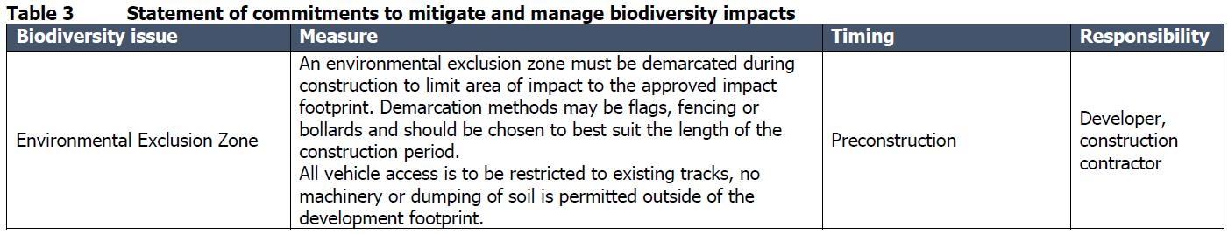  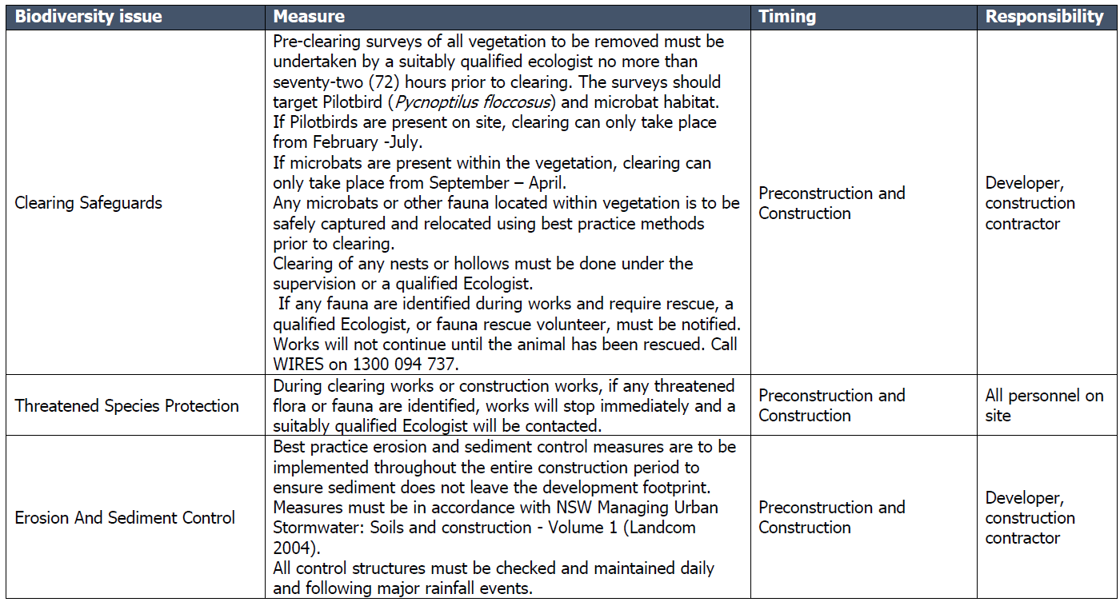  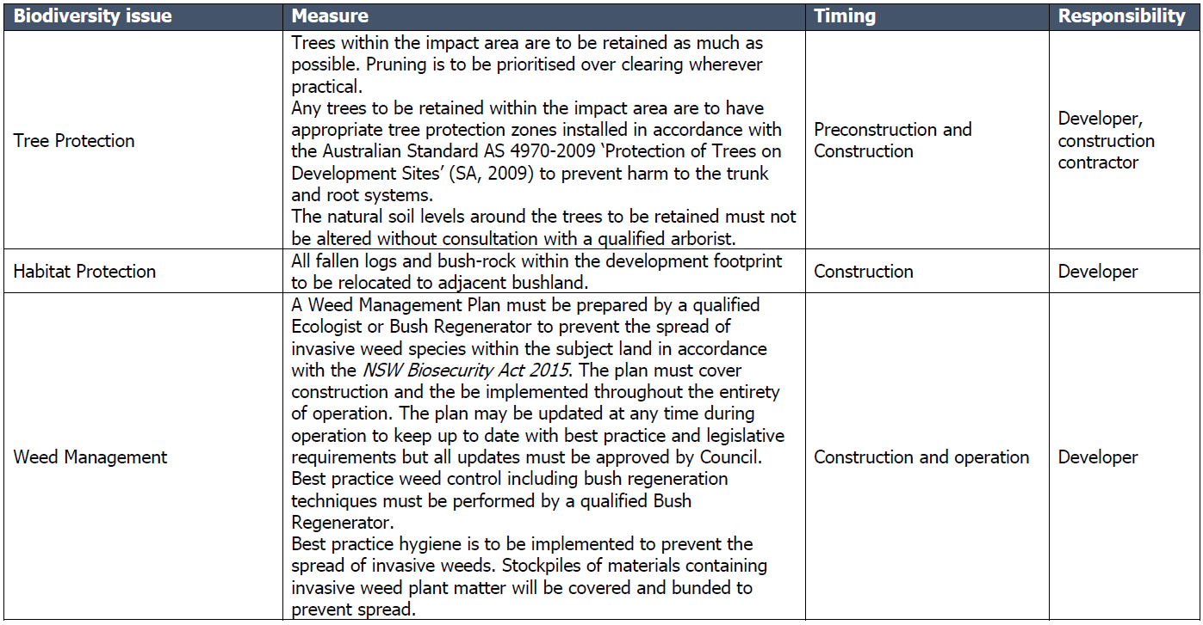  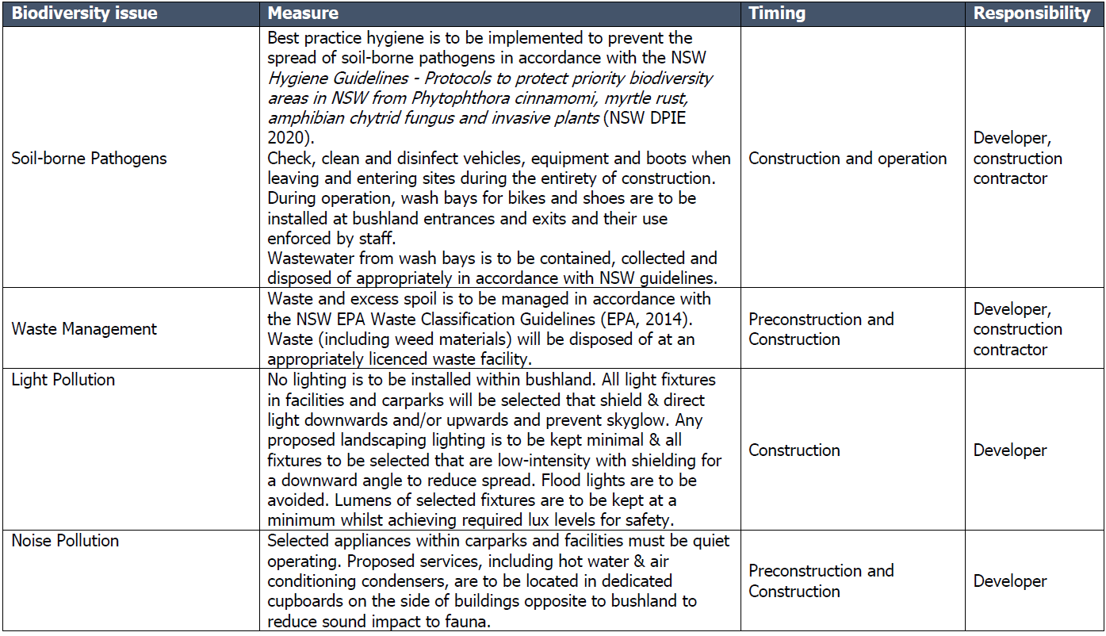  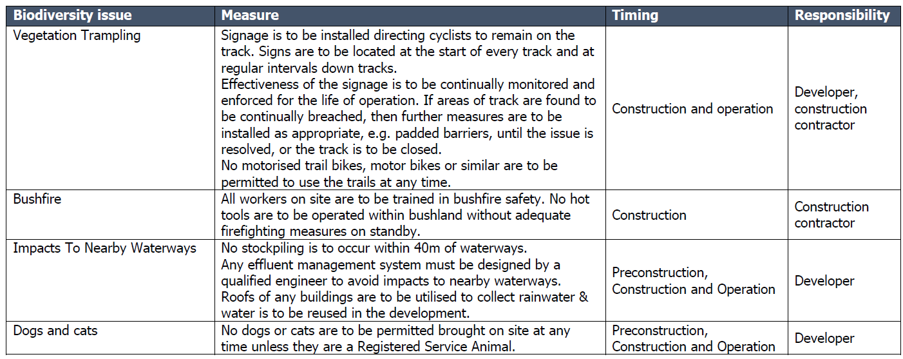
51. | Condition Reason: To comply with the Biodiversity Conservation Act 2016.

BEFORE BUILDING WORK COMMENCES
52. | Certification  Prior to commencing any construction works, the following requirements of the Environmental Planning and Assessment Act 1979 are to be complied with:  - A principal certifier is appointed in accordance with section 6.6(1) of the Act, and  - If the principal certifier is not Council, Council has been notified of the appointment of the principal certifier no later than 2 days before building work commences in accordance with section 6.6(2) of the Act, and  - A construction certificate has been issued for the building works in accordance with section 6.7 of the Act, and  - Council has been given at least 2 days’ notice of the intention to commence building works in accordance with section 6.6(2)(e) of the Act.
52. | Condition Reason: To ensure compliance with the Environmental Planning and Assessment (Development Certification and Fire Safety) Regulation 2021.
53. | Set-Out Survey Required  Prior to commencing any construction works, a set-out survey (prepared by a registered practising Surveyor) is to be submitted to the Principal Certifier nominating the location of the development in accordance with the Stamped Documentation & Plans.  Such a survey is to show the location of slab formwork in relation to other buildings on-site and the allotment boundaries.
53. | Condition Reason: To ensure compliance with the Environmental Planning and Assessment (Development Certification and Fire Safety) Regulation 2021.
54. | Site Requirements  - Prior to the commencement of any works, a hoarding or fence must be erected between the work site and a public place, where practicable.  - If the work involved in the development is likely to cause pedestrians and/or vehicular traffic in a public place to be obstructed or rendered inconvenient and/or if the building involves the enclosure of a public place, it must be undertaken in accordance with WorkCover requirements.  - The works site must be kept lit between sunset and sunrise if it is likely to be hazardous to persons in the public place.  - Prior to commencement of any building works, a suitable lidded waste container or enclosure for the deposit of all potential windborne building rubbish and litter must be provided onsite.  - The waste container must be emptied at a licensed waste disposal facility when full.  - All building rubbish and litter must be contained on the building site and the site left clear of waste and debris upon completion of works.  - Prior to the commencement of any works on the land, a sign/s must be erected in a prominent position on the site:  - Showing the name of the principal contractor (if any) for any building work and a telephone number on which that person can be contacted outside working hours.  - Stating that unauthorised entry to the work site is prohibited and  - Showing the name, address and telephone number of the principle certifying authority for the work.  - The sign/s are to be maintained while the building work, subdivision work or demolition work is being carried out, but must be removed when the work has been completed.  - Prior to the commencement of any works on the land, toilet facilities must be provided for construction personnel on the site on the basis of 1 toilet for every 20 workers.  - Amenities are to be installed and operated in an environmentally responsible and sanitary manner.  - Toilets cannot remain on site for any longer than 12 months, without the further approval of Council.
54. | Condition Reason: To ensure site management measures are implemented during the carrying out of site work.
55. | Erosion and sediment controls in place  Before any site work commences, the Principal Certifier, must be satisfied the erosion and sediment controls in the erosion and sediment control plan are in place. These controls must remain in place until any bare earth has been restabilised in accordance with the NSW Department of Housing manual ‘Managing Urban Stormwater: Soils and Construction Certificate’ (the Blue Book) (as amended from time to time).
55. | Condition Reason: To ensure sediment laden runoff and site debris do not impact local stormwater systems and waterways.
56. | Protection of adjoining areas  A temporary hoarding or temporary construction site fence must be erected between the work site and adjoining lands before the works begin, and must be kept in place until after the completion of works, where practicable, if the works—  (a) could cause a danger, obstruction or inconvenience to pedestrian or vehicular traffic, or  (b) could cause damage to adjoining lands by falling objects, or  (c) involve the enclosure of a public place or part of a public place.
56. | Condition Reason: To ensure site management measures are implemented during the carrying out of site work.
57. | Toilet facilities  Toilet facilities are to be provided, at or in the vicinity of the work site on which work involved in the erection or demolition of a building is being carried out, at the rate of one toilet for every 20 persons or part of 20 persons employed at the site.
57. | Condition Reason: To ensure site management measures are implemented during the carrying out of site work
58. | Garbage receptacle  A garbage receptacle must be provided at the work site before works begin and must be maintained until the works are completed. The garbage receptacle must have a tight-fitting lid and be suitable for the reception of food scraps and papers
58. | Condition Reason: To ensure site management measures are implemented during the carrying out of site work
59. | Plumbing and/or drainage works  Prior to the comment of any plumbing and/or drainage work, a Notice of Works is to be submitted to Council from the licensed plumber contractor in accordance with the Plumbing and Drainage Act.
59. | Condition Reason: To ensure the development is serviced by a suitable plumbing and/or drainage works in accordance with the Plumbing and Drainage Act.
60. | Traffic Control Plan  A fully certified traffic control plan will be required where machinery may obstruct traffic on public roads whilst construction work is being undertaken. Failure to comply may result in Work Cover intervention and may also include Stop Work orders from Council until such time the developer complies with suitable traffic management procedures.  The Traffic Control/Management Plan is to include a Driver Code of Conduct to manage construction traffic impacts on the wider network.
60. | Condition Reason: To ensure minimal impact is made to traffic in the area.
61. | Council Assets  Prior to the commencement of any works on site, the applicant shall advise Council of any damage to property controlled by Council which adjoins the site including kerbs, gutters, footpaths, walkways, reserves and the like. Failure to identify existing damage will result in all damage detected after completion of the building work being repaired at the applicant’s expense.
61. | Condition Reason: To ensure minimal impact is made to Council assets.
62. | Retaining walls  Prior to the commencement of work in relation to any carpark retaining walls over 600mm in height a Construction Certificate is to be obtained under Part 3 of Environmental Planning & Assessment (Development Certification and Fire Safety) Regulation 2021.
62. | Condition Reason: To comply with Part 3 of Environmental Planning & Assessment (Development Certification and Fire Safety) Regulation 2021.
63. | Engineering Requirements  - Any driveway construction works (new or replacement of existing driveway access) needs to comply with Council’s Policy 10.18 – Specification for the Construction of Driveways, Footpath/Gutter Crossing and Footpaving (available on Council’s website). The application fee for the inspection is required to be paid prior to inspection being undertaken. Notification of at least 48 hours is required to arrange inspections (no inspection undertaken on Fridays). Further information can be obtained regarding Driveway approvals by contacting Council’s Infrastructure Services Department on (02) 6354 9904 during business hours.  - Vehicular access and manoeuvring associated with the subject development shall be designed in accordance with AS 2890.1.  - Applicant shall comply with the Traffic impact and assessment study prepared Traffic Engineering Centre rev C dated 12.08.2025.  - A civil construction works certificate will be required to be lodged to Council prior to the commencement of any Civil Works.  - All road and right of carriageway construction is to be to the standard specified in Council’s “Guidelines for Civil Engineering Design and Construction for Development”. This document is available on Council’s website or upon request from Council’s administration desk.  - The applicant shall ensure that during the construction works all measures are taken to eliminate/suppress any dust nuisance emanating from the site.  - Effective erosion and sediment controls shall be installed prior to any construction activity including dwelling site access. The controls must prevent sediment entering drainage depressions and watercourses, and shall be regularly maintained and retained until works have been completed and groundcover established.  - All road, drainage, kerb and gutter, water and sewerage reticulation works associated with a development will be inspected by Council’s Operations Department. The developer shall at all times give uninterrupted access and afford every facility for the examination for any works and materials requested by the Group Manager of Operations or his authorised delegate.  - All stormwater drainage is the responsibility of the applicant and shall be satisfactorily disposed of into Council’s stormwater infrastructure.  - A suitably qualified stormwater consultant or engineer shall certify in writing to Water NSW and Council prior to issuance of an Occupation Certificate that all stormwater management structures have been installed as per these conditions of consent and are in a functional state.  - The management strategies/traffic controls outlined within the Traffic Impact Assessment is to be consulted with Council and approved by Council prior to works being undertaken, to determine the location of signage, vegetation removal on Council’s Road Reserve, Road Markings, speed limits etc. All undertakings are to be at full cost to the applicant.
63. | Condition Reason: To comply with Council’s Engineering requirements.
64. | Roads Act 1993  The proponent is required to obtain approvals under section 138 of the Roads Act 1993 in relation to any proposed works or structures on roads, including road reserves. This includes a Road Opening Permit Application.  The proponent is required to enter a contract with Council in relation to use of public roads vested in Council. Such contract may be subject to the approval of the Secretary of the Department of Planning and Environment under section 149 of the Roads Act 1993.
64. | Condition Reason: To comply with Council’s Engineering requirements and Roads Act 1993.
65. | Unexpected Finds Protocol  An Unexpected Finds Protocol (UFP) is to be established to guide contractors and environmental consultants in identifying and managing unforeseen contamination, including asbestos, heavy metals, and other hazardous materials.
65. | Condition Reason: This protocol will ensure that unexpected finds are managed in a safe, compliant manner, minimising potential risks to workers, future users, and the environment.

DURING CONSTRUCTION WORK
66. | Compliance with plans  (1) Works must be carried out in accordance with the plans and specifications to which the complying development certificate relates.  (2) A copy of the stamped and approved plans, development consent and the construction certificate are to be on the site at all times.
66. | Condition Reason: To ensure the development complies with the approved plans.
67. | Maintenance of site  (1) All materials and equipment must be stored wholly within the work site unless an approval to store them elsewhere is held.  (2) Waste materials (including excavation, demolition and construction waste materials) must be managed on the site and then disposed of at a waste management facility.  (3) Copies of receipts stating the following must be given to the principal certifying authority—  (a) the place to which waste materials were transported,  (b) the name of the contractor transporting the materials,  (c) the quantity of materials transported off-site and recycled or disposed of.  (4) Any run-off and erosion control measures required must be maintained within their operating capacity until the completion of the works to prevent debris escaping from the site into drainage systems, waterways, adjoining properties and roads.  (5) During construction—  (a) all vehicles entering or leaving the site must have their loads covered, and  (b) all vehicles, before leaving the site, must be cleaned of dirt, sand and other materials, to avoid tracking these materials onto public roads.  (6) At the completion of the works, the work site must be left clear of waste and debris.
67. | Condition Reason: To ensure minimal impact to the environment.
68. | Construction hours  Construction may only be carried out between 7.00 am and 5.00 pm on Monday to Saturday and no construction is to be carried out at any time on a Sunday or a public holiday.
68. | Condition Reason: To protect the amenity of the surrounding area.
69. | Site management  All materials and equipment must be stored wholly within the work site unless an approval to store them elsewhere is held. Waste materials (including excavation, demolition and construction waste materials) must be managed on the site and then disposed of at a waste management facility.
69. | Condition Reason: To ensure site management measures are implemented during the carrying out of site work.
70. | External colours and finishes  The development shall incorporate colours and finishes that are consistent with the approved plans and schedule.
70. | Condition Reason: To ensure the development complies with the approved plans and referenced documents.
71. | Earthworks  Any earthworks (including any structural support or other related structure for the purposes of the development:  - Must not cause a danger to life or property or damage to any adjoining building or structure on the lot or to any building or structure on any adjoining lot, and  - Must not redirect the flow of any surface or ground water or cause sediment to be transported onto an adjoining property, and  - That is fill brought to the site—must contain only virgin excavated natural material (VENM) as defined in Part 3 of Schedule 1 to the Protection of the Environment Operations Act 1997, and  - That is excavated soil to be removed from the site—must be disposed of in accordance with any requirements under the Protection of the Environment Operations (Waste) Regulation 2005.  - Any excavation must be carried out in accordance with Excavation Work: Code of Practice (ISBN 978-0-642-785442), published in July 2012 by Safe Work Australia.
71. | Condition Reason: To ensure site management measures are implemented during the carrying out of site work.
72. | Compaction of fill  - Any filling carried out in accordance with this consent shall maintain a minimum requirement of 98% standard compaction.  - Any lot filling operations carried out in accordance with this consent shall be tested to establish the field dry density every 300mm rise in vertical height. Test sites shall be located randomly across the fill site with 1 test per 500m² (minimum 1 test per 300mm layer) certified by a qualified geotechnical engineer. Alternatively, all footings/piers are to be taken through filled ground to foundation material of uniform adequate bearing pressure in accordance with Structural Engineers requirements.  Note: A compaction report from a Geotechnical Engineer or Engineering structural plans/details for any proposed piers through fill, shall be submitted to the Principal Certifying Authority prior to the slab steel inspection.  - Fill material used must be virgin excavated natural material within the meaning of the Protection of Environmental Operations Act 1997 (POEO) or any other waste- derived material the subject of a resource recovery exemption under cl.51A of the Protection of the Environment Operations (Waste) Regulation 2005 that is permitted to be used as fill material.  Note: Any waste-derived material the subject of resource recovery exemption received at the development site must be accompanied by documentation as to the material’s compliance with the exemption conditions and must be provided to the Principal Certifying Authority.
72. | Condition Reason: To ensure site management measures are implemented during the carrying out of site work.
73. | Procedure for critical stage inspections  While building work is being carried out, the work must not continue after each critical stage inspection unless the principal certifier is satisfied the work may proceed in accordance with this consent and the relevant construction certificate.
73. | Condition Reason: To require approval to proceed with building work following each critical stage inspection.
74. | Plumbing and/or drainage works  All plumbing and drainage work must be carried out by a licensed plumber and drainer in accordance with the requirements of Australian Standard 3500 and Complying with the Plumbing Code of Australia (PCA) and all relevant Australian Standards.
74. | Condition Reason: To ensure the development is serviced by a suitable plumbing and/or drainage works.
75. | Plumbing and/or drainage works inspections  Forty-eight (48) hours’ notice shall be given to Lithgow City Council for inspection of the following plumbing and drainage works:  - Internal and external drainage lines prior to backfilling.  - The licensed plumber/drainer shall be on site at the site of the inspection, and the drainage lines shall be charged and under test.  - Hot and cold water installations under test bucket pressure of 1500kpa.  - On completion of all plumbing drainage and sanitary fixture installations.
75. | Condition Reason: To ensure the development is serviced by a suitable plumbing and/or drainage works.
76. | Plumbing and/or drainage Certificate of Compliance  Prior to the issue of a Certificate of Compliance for all sanitary plumbing and drainage, the plumbing and drainage works are to be inspected and approved by Lithgow City Council as the delegated regulatory authority for plumbing and drainage works within the Lithgow City Council area.
76. | Condition Reason: To ensure the development is serviced by a suitable plumbing and/or drainage works.
77. | Vehicle Movements  All vehicles entering or leaving the site must have their loads covered, and before leaving the site, must be cleaned of dirt, sand and other materials, to avoid tracking these materials onto public roads.
77. | Condition reason: To promote safe entry and exit to the construction site.
78. | Excavated Areas  Excavated area/s adjacent to the development site shall be retained and drained to prevent the subsidence of the excavation and/or entry of surface water.
78. | Condition reason: To ensure all earthworks are adequately retained.
79. | Dust  The Applicant shall ensure that during the construction works all measures are taken to eliminate/suppress any dust nuisance emanating from the site.
79. | Condition Reason: To ensure site management measures are implemented during the carrying out of site work.
80. | Waste management  Waste materials (including excavation, demolition and construction waste materials) must be managed on the site and then disposed of at a waste management facility. Copies of receipts stating the following must be given to the principal certifying authority—  (a) the place to which waste materials were transported,  (b) the name of the contractor transporting the materials,  (c) the quantity of materials transported off-site and recycled or disposed of.
80. | Condition Reason: To promote safe and responsible disposal of waste.
81. | Contamination  Should any suspect materials (identified by unusual staining, odour, discoloration or inclusions such as building rubble, asbestos, ash material, etc) be encountered during any stage of works (including earthworks, site preparation or construction works, etc) such works shall cease immediately until a qualified environmental specialist has been contact and conducted a thorough assessment.  In the event that contamination is identified as a result of this assessment and if remediation is required, all works must cease in the vicinity of the contamination, and Council must be notified.
81. | Condition Reason: To ensure potential contamination is appropriately managed and mitigated onsite.
82. | Archaeology discovered during excavation  If any object having interest due to its age or association with the past is uncovered during the course of the work—  (a) all work must stop immediately in that area, and  (b) the Office of Environment and Heritage must be advised of the discovery.  Note. Depending on the significance of the object uncovered, an archaeological assessment and excavation permit under the Heritage Act 1997 may be required before further the work can continue.
82. | Condition reason: To ensure potential archaeology is appropriately managed.
83. | Aboriginal objects discovered during excavation  If any Aboriginal object (including evidence of habitation or remains) is discovered during the course of the work—  (a) all excavation or disturbance of the area must stop immediately in that area, and  (b) the Office of Environment and Heritage must be advised of the discovery in accordance with section 89A of the National Parks and Wildlife Act 1974.  Note. If an Aboriginal object is discovered, an Aboriginal heritage impact permit may be required under the National Parks and Wildlife Act 1974.
83. | Condition reason: To ensure potential archaeology is appropriately managed.
84. | Biodiversity Protection  The Biodiversity Management strategies within the application is to be complied with. This includes:  • Install high visibility flagging and signage during the construction process to protect adjacent trees and areas of native vegetation.  • Install sediment fencing and signage during the construction process to prevent sediment from being deposited in areas outside of the construction zone.  • A fauna spotter-catcher should be employed to inspect trees, rocks and logs that may be removed immediately prior to clearing and to move any animals into adjacent areas of habitat.  • Disturbance to rocks and large woody debris should be undertaken in a slow and cautious manner, e.g. by gently lowering trees to the ground where feasible.  • Works involving disturbance to trees, rocks and large woody debris should be supervised by a fauna spotter catcher who should capture any animals seen – the spotter-catcher should move uninjured animals into adjacent areas of habitat and seek veterinary assistance and rehabilitation for any injured animals  • Logs and rocks removed should be placed at the edge of the disturbed area to enable their use as habitat by native animals.  • Machinery should arrive on-site clean to reduce the chance of spreading weeds or any diseases.
84. | Condition reason: To ensure protection to the environment.
85. | Community land  During construction and ongoing operation of the mountain bike park, the following objectives must be observed and implemented in relation to Lots 1 to 3 in DP1110346:  - ensure the ongoing ecological viability of the land by protecting the ecological biodiversity and habitat values of the land, the flora and fauna (including invertebrates, fungi and micro-organisms) of the land and other ecological values of the land;  - protect the aesthetic, heritage, recreational, educational and scientific values of the land;  - promote the management of the land in a manner that protects and enhances the values and quality of the land and facilitates public enjoyment of the land, and to implement measures directed to minimising or mitigating any disturbances caused by human intrusion;  - restore any degraded bushland directly created via the works to construct the development;  - protect existing landforms such as natural drainage lines, watercourses and foreshores;  - retain bushland in parcels of a size and configuration that will enable the existing plant and animal communities to survive in the long term; and  - protect bushland as a natural stabiliser of the soil surface.
85. | Condition reason: To ensure compliance with section 36J the Local Government Act 1993.
86. | Exclusive use of land  Prior to commencing construction, the relevant party must enter a licence with Council in relation to Lots 1 to 3 on terms to be agreed by Council.
86. | Condition reason: To ensure compliance Part 2 of Chapter 6 of the Local Government Act 1993.

BEFORE ISSUE OF AN OCCUPATION CERTIFICATE
87. | Visual Barriers, Geographical Barriers & Fencing  Visual and geographical barriers are to be established to protect the privacy of adjoining residential properties that share a boundary with the development. The type of visual barrier is to be chosen in consultation with the relevant property owners.  These measures are to be established prior to operational use of the site.
87. | Condition reason: To ensure safety and privacy impacts are reduced to adjoining residential areas.
88. | Disturbed areas  The disturbed areas surrounding the building work shall be reinstated to the satisfaction of the Principal Certifier upon completion of the work.
88. | Condition reason: To ensure no substance other than rainwater enters the stormwater system and waterways.
89. | Certificate of Compliance – Council Wastewater  - An application for the Certificate of Compliance for all water and sewerage Supply works shall be submitted by the applicant to Council upon completion of the works and prior to the issue of Occupation Certificate. This application must be accompanied by all relevant plumbing, drainage and civil works details associated with the water and sewerage supply, including Work as Executed drawings.  - As constructed internal sewer drainage diagram showing connection to the sewer tie and location of Sewer Boundary Riser (DN150) shall be submitted and approved by Council prior to occupation.  - A Certificate of Compliance issued under the Water Management Act 2000 only covers the water and sewerage supply works that are not defined as plumbing and drainage work within the meaning of the Plumbing and Drainage Act 2011.  - A Certificate of Compliance must be issued prior to the release of the Occupation Certificate. In accordance with Section 306(2) of the Water Management Act 2000, a precondition to the issue of the Certificate of Compliance is that all applicable development contributions (where relevant) have been paid and all water and/or sewerage conditions of consent have been satisfied.  - In accordance with Section 307 Water Management Act 2000 Council may impose a requirement on the applicant to address outstanding matters. Where a matter remains unresolved, Council may be satisfied that a requirement has been complied with if the applicant lodges with the Council such security to cover the cost of ensuring full compliance.  - All works proposed and conditions under the S68 approval must be completed prior to Occupational Certificate application.
89. | Condition Reason: To ensure the development is serviced by a suitable plumbing and/or drainage works.

OCCUPATION AND ONGOING USE
90. | Occupation Certificate  The development shall not be occupied or used until an Occupation Certificate is issued by the Principal Certifier.
90. | Condition reason: To ensure compliance with the Environmental Planning and Assessment (Development Certification and Fire Safety) Regulation 2021.
91. | Exclusive use of land  Prior to commencing operation of the mountain bike park, the relevant party must enter a lease with Council in relation to Lots 1 to 3 on terms to be agreed by Council.
91. | Condition reason: To ensure compliance Part 2 of Chapter 6 of the Local Government Act 1993.
92. | External Lighting and CCT  All external lighting and CCT cameras are to be directed to within the property boundaries, ensuring all lighting is downwards pointing. Lighting and CCT cameras are not to be directed towards the street or towards adjoining neighbouring properties to avoid creating a nuisance to those receivers.  All lighting is to comply with AS4282.
92. | Condition Reason: To minimise adverse impacts to adjoining property owners.
93. | Waste Disposal  All waste material is to be placed within the waste bins provided and taken to an approved Waste Facility via an external contractor on a daily basis.
93. | Condition Reason: To minimise impacts to the environment.
94. | Signage  - All ingress and egress points to be well defined and clearly marked with signage and traffic flow.  - Site management hours, safety precautions and bushfire safety procedures.  - Include signage indicating CCTV in operation and security patrols on premises.  - Include signage notifying emergency contact details.
94. | Condition Reason: To minimise impacts to adjoining property owners.

PRESCRIBED CONDITIONS
Environmental Planning and Assessment Regulation 2021
95. | Erection of signs  (1) This section applies to a development consent for development involving building work, subdivision work or demolition work.  (2) It is a condition of the development consent that a sign must be erected in a prominent position on a site on which building work, subdivision work or demolition work is being carried out—  (i) showing the name, address and telephone number of the principal certifier for the work, and  (ii) showing the name of the principal contractor, if any, for the building work and a telephone number on which the principal contractor may be contacted outside working hours, and  (iii) stating that unauthorised entry to the work site is prohibited.  (3) The sign must be—  (i) maintained while the building work, subdivision work or demolition work is being carried out, and  (ii) removed when the work has been completed.  (4) This section does not apply in relation to—  (i) building work, subdivision work or demolition work carried out inside an existing building, if the work does not affect the external walls of the building, or  (ii) Crown building work certified to comply with the Building Code of Australia under the Act, Part 6.
95. | Condition reason: Prescribed condition (Environmental Planning and Assessment Regulation 2021).
96. | Shoring and adequacy of adjoining property  (1) This section applies to a development consent for development that involves excavation that extends below the level of the base of the footings of a building, structure or work on adjoining land, including a structure or work in a road or rail corridor.  (2) It is a condition of the development consent that the person having the benefit of the development consent must, at the person’s own expense—  (i) protect and support the building, structure or work on adjoining land from possible damage from the excavation, and  (ii) if necessary, underpin the building, structure or work on adjoining land to prevent damage from the excavation.  (3) This section does not apply if—  (i) the person having the benefit of the development consent owns the adjoining land, or  (ii) the owner of the adjoining land gives written consent to the condition not applying.
96. | Condition reason: Prescribed condition (Environmental Planning and Assessment Regulation 2021).

General advisory notes
This consent contains the conditions imposed by the consent authority which are to be complied with when carrying out the approved development. However, this consent is not an exhaustive list of all obligations which may relate to the carrying out of the development under the EP&A Act, EP&A Regulation and other legislation.

The approved development must be carried out in accordance with the conditions of this consent. It is an offence under the EP&A Act to carry out development that is not in accordance with this consent.

BUILDING WORK

Building work must not be carried out until a construction certificate, respectively, has been issued and a principal certifier has been appointed.

A document referred to in this consent is taken to be a reference to the version of that document which applies at the date the consent is issued, unless otherwise stated in the conditions of this consent.

Schedule B- GENERAL TERMS OF APPROVAL, SUBSIDENCE ADVISORY

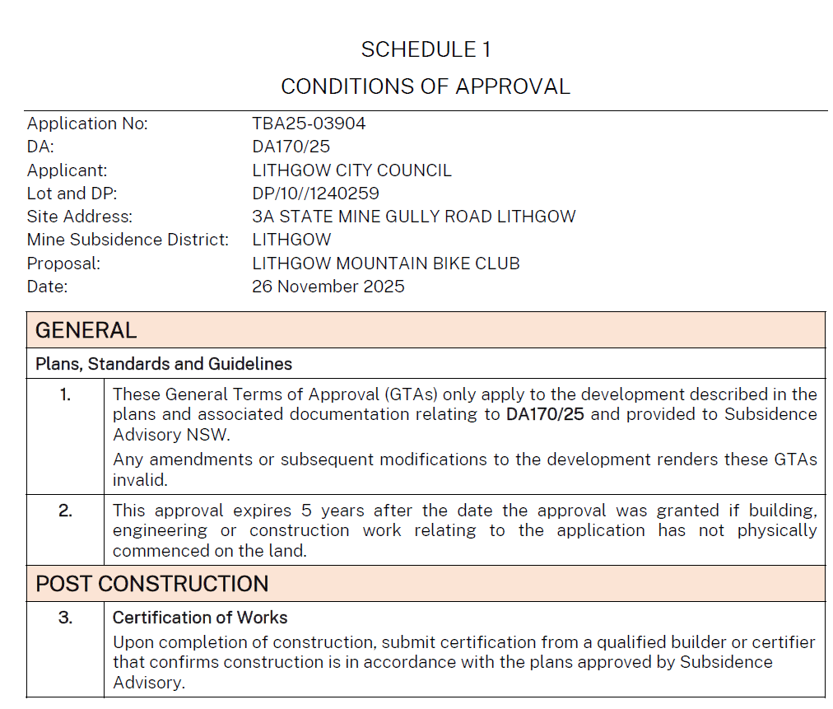

Schedule C- GENERAL TERMS OF APPROVAL, DEPARTMENT OF CLIMATE CHANGE, ENERGY, the ENVIRONMENT and WATER- WATER GROUP
